Create deployment

apiVersion: apps/v1

kind: Deployment

metadata:

name: golang-http

labels:

app: golang-http

spec:

replicas: 1

selector:

matchLabels:

app: golang-http

template:

metadata:

labels:

app: golang-http

spec:

containers:

- name: golang-http

image: bashayralabdullah/golang-http:v1.0

imagePullPolicy: Always

ports:

- containerPort: 8080

protocol: TCP

**Step 2: Create a Service**

Create service

kind: Service

apiVersion: v1

metadata:

name: golang-http

labels:

app: golang-http

spec:

ports:

- protocol: TCP

port: 8080

targetPort: 8080

selector:

app: golang-http

type: ClusterIP

Note down the service ip

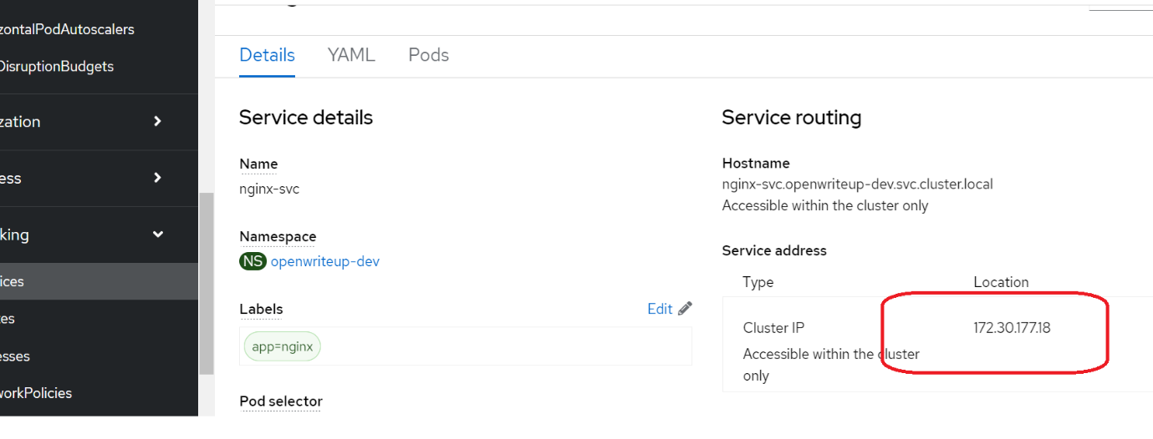

Create HPA

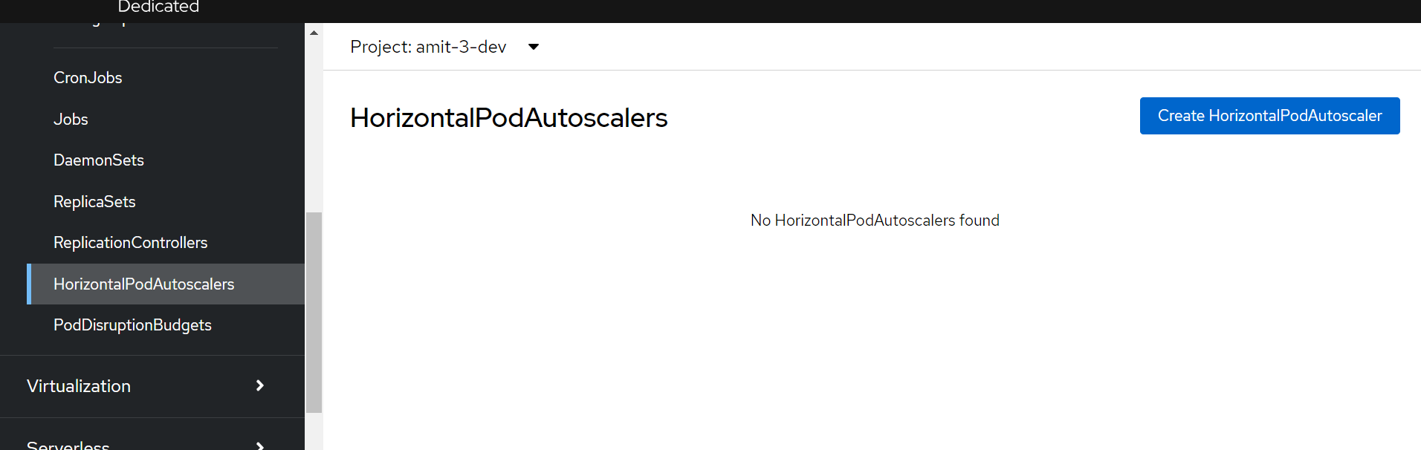

apiVersion: autoscaling/v2  
kind: HorizontalPodAutoscaler  
metadata:  
 name: nginx-hpa  
spec:  
 scaleTargetRef:  
 apiVersion: apps/v1  
 kind: Deployment  
 name: golang-http  
 minReplicas: 1  
 maxReplicas: 10  
 metrics:  
 - type: Resource  
 resource:  
 name: cpu  
 target:  
 type: Utilization  
 averageUtilization: 20

Go to networking->Get the ip of service🡪replace in below command

apiVersion: v1  
kind: Pod  
metadata:  
 name: load-generator  
spec:  
 containers:  
 - name: busybox  
 image: busybox  
 command: ["/bin/sh"]  
 args: ["-c", "while true; do wget -q -O- http://172.30.101.82:8080; done"]

Pod status before generate load:

kubectl top po

kubectl get po